**(2012)**

**Task 1: Dynamic Systems (25%) (2012)**

1. To describe dynamic systems, one often uses models which differ according to their number of inputs and outputs. Describe two of these dynamic systems in general in a sketch and give one example for each model in reality.

|  |  |
| --- | --- |
|  | Ex for SISO: Cruise Control or Audio Device  Ex for MIMO: Large Modern Telescopes |

1. In control theory, the names of the controlled systems (= dynamic systems) are often defined by characteristics of their step response. Enter the name of the system in the appropriate box underneath the corresponding step response in Figure 6. Write down the differential equation for each system shown and explain the respective quantities.

|  |
| --- |
|  |

**Task 2: Closed Control-Loops (35%) (2012)**

a) For autonomic guidance of construction machines it is necessary to find the

appropriate control algorithm to reach a high control quality. In control engineering

there are a variety of controllers which may be used. All of them have one thing in

common. They have to be integrated into a closed-loop system. Explain the basics of a closed-loop system and show the general variables which are integrated. Please use a sketch.

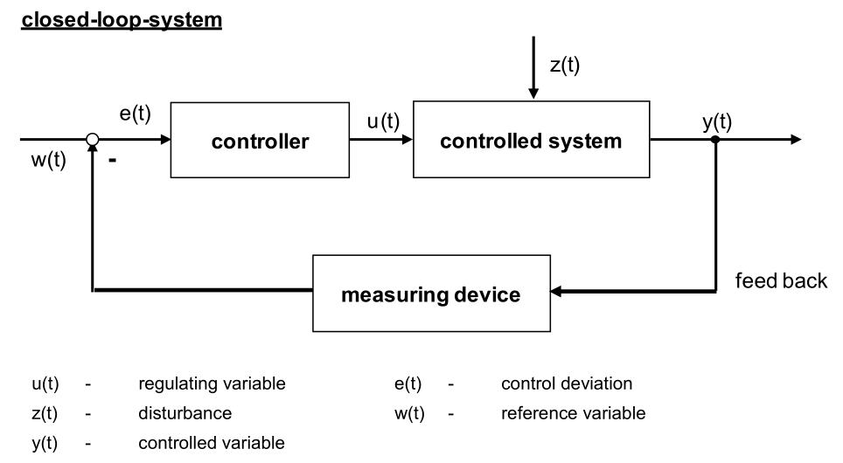

b) Now you have the task to design a control loop for an automated caterpillar plate

height control (only the up and down movement of the plate). As reference you can

use a digital terrain model. Choose a measurement sensor for the height to

guarantee an accuracy of at least 2 cm. Give reasons for your choice. Replace the

terms of 2.1. with the terms you need for this task and draw the closed control-loop in a sketch.

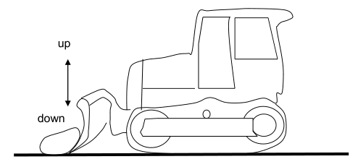

c) Today closed-loop-systems are used for guiding and controlling construction

machines on construction sites. Usually one speaks of the inner closed-loop-system.

Explain the outer closed-loop-system and show the relationship between the outer

and inner closed-loop-system for the construction of a building in a sketch. Name all

main items of the outer and inner closed-loop-system and place them in the sketch.

**Task 3: Robot Tachymeters (40%) (2012)**

a) Beside GPS, robot-tachymeters are used for positioning within the scope of

construction machine control. Modern robot-tachymeters consist of a variety of

components. Please show the system architecture in a sketch and describe three

components in more detail.

|  |
| --- |
|  |

b) If a one-man-total-station is used for example for stake-out tasks, sometimes the total station (robot tachymeter) loses the target (360-degree prism). To find the target again different realizations are explained in the lecture. Name the general method which brings the target again in range of vision of the total-station. Explain two realizations.

|  |
| --- |
| Rough pointing: recognition of target points without pre-information.  Finished if reflector is on telescope’s range of vision.  Realizations:   1. **Special sensors for rough pointing (Leica Powersearch)**   -Reflection is detected at tachymeter (passive reflector)  -Laser plane (α<= 110°)  -Horizontal rotation -> detect Hz angle (50 mgon accuracy)  -Vertical angle > use of laser beam (50-70 mgon accuracy)   1. **Use of Active reflectors (Trimble)**   -Laser plane (α=10°)  -Reflector transmits the signal back to the instrument via modulated laser or infrared signal.  -Reflector is uniquely identified. |

c) Describe the difference between synchronization error and dead time for a robot

tachymeter with your own words. You may use sketches.

|  |
| --- |
| - Dead time is the time needed to communicate the data transmission.  - Synchronization error appears due the time difference between different durations of measurement sensors. (Reduced by starting the measurements at different times for each sensor) |

d) A modern robot tachymeter consists of a variety of different sensors. The most

important ones for the measurement of positions are four sensors. There are two known ways to synchronize these four sensors. Name these four sensors and draw the two types of synchronization in a sketch. Explain the benefit of the better way with respect to the other one. What could be done additionally to get a better result for the position?

|  |
| --- |
|  |